**BEGINNING OF TERM III EXAMINATION - 2024**

**PRIMARY ONE- READING**

NAME: ___________________________________

STREAM: _______________________________

**INSTRUCTIONS:**

1. Read well and answer all questions.

2. You must write well.

3. Write correct spellings and answer in full sentences where necessary.

1. Listen and write

______________________

______________________

______________________

______________________

______________________

1. Make words using these sounds

______________

gr

______________

a ________________

ble nd ________________

e ________________

1. Read the questions and circle the correct answer.
2. How many letters make the word transport?

two seventeen nine ninety

1. Which letter is a consonant?

s a e i o

1. Which word is without a vowel?

cat bag sky shirt

1. Which letter is a vowel?

p s b t u

1. Circle the word with sound ‘ee’

basket keep bench belt

1. Complete the riddles correctly.
2. I am made of palm leaves

People sit or sleep on me

Who am I? You are a ________________

1. I am a means of transport

I sail on water

Who am I? ________________________

1. I am an animal

I give you milk and beef

Who am I? _________________________

1. Make correct sentences using these words

Ship _______________________________________

Sheep _____________________________________

1. Underline words with sound “br” in the story.

One day, we went to Brazil for a holiday break. My mother and brother stayed there. We only ate bread and the baby was given breast milk. I also enjoyed brightly coloured flowers so much.

1. Write words using the following sounds

st___________ dr _____________

g ____________ n ______________

pr ___________

1. Form a correct story.

Then we also go and dig.

He also wakes us too.

When it is a rainy day

To harvest some water

Father wakes up early to dig.

_________________________________

_________________________________

_________________________________

_________________________________

_________________________________

1. Read and draw

Joy is carrying a pot

There are two bags on the table

Tom is wearing a hat on the head.

The man is pushing a wheelbarrow

She is pointing at the aeroplane.

1. Read the rhyme and answer the questions in full sentences.

Up in the forest

There’s a big tall tree

Woodman woodman

cut down the big tall tree

Timber lorry timber lorry

Take it to the carpenter

carpenter carpenter

make a chair for me

***By Tinu***

1. Who wrote the rhyme?

_________________________________

1. Where is the big tall tree?

_________________________________

1. Who is to cut the big tall tree?

_________________________________

1. Who will make a chair?

_________________________________

1. How many lines has the rhyme?

_________________________________

1. Study the pictures carefully and answer the questions correctly.

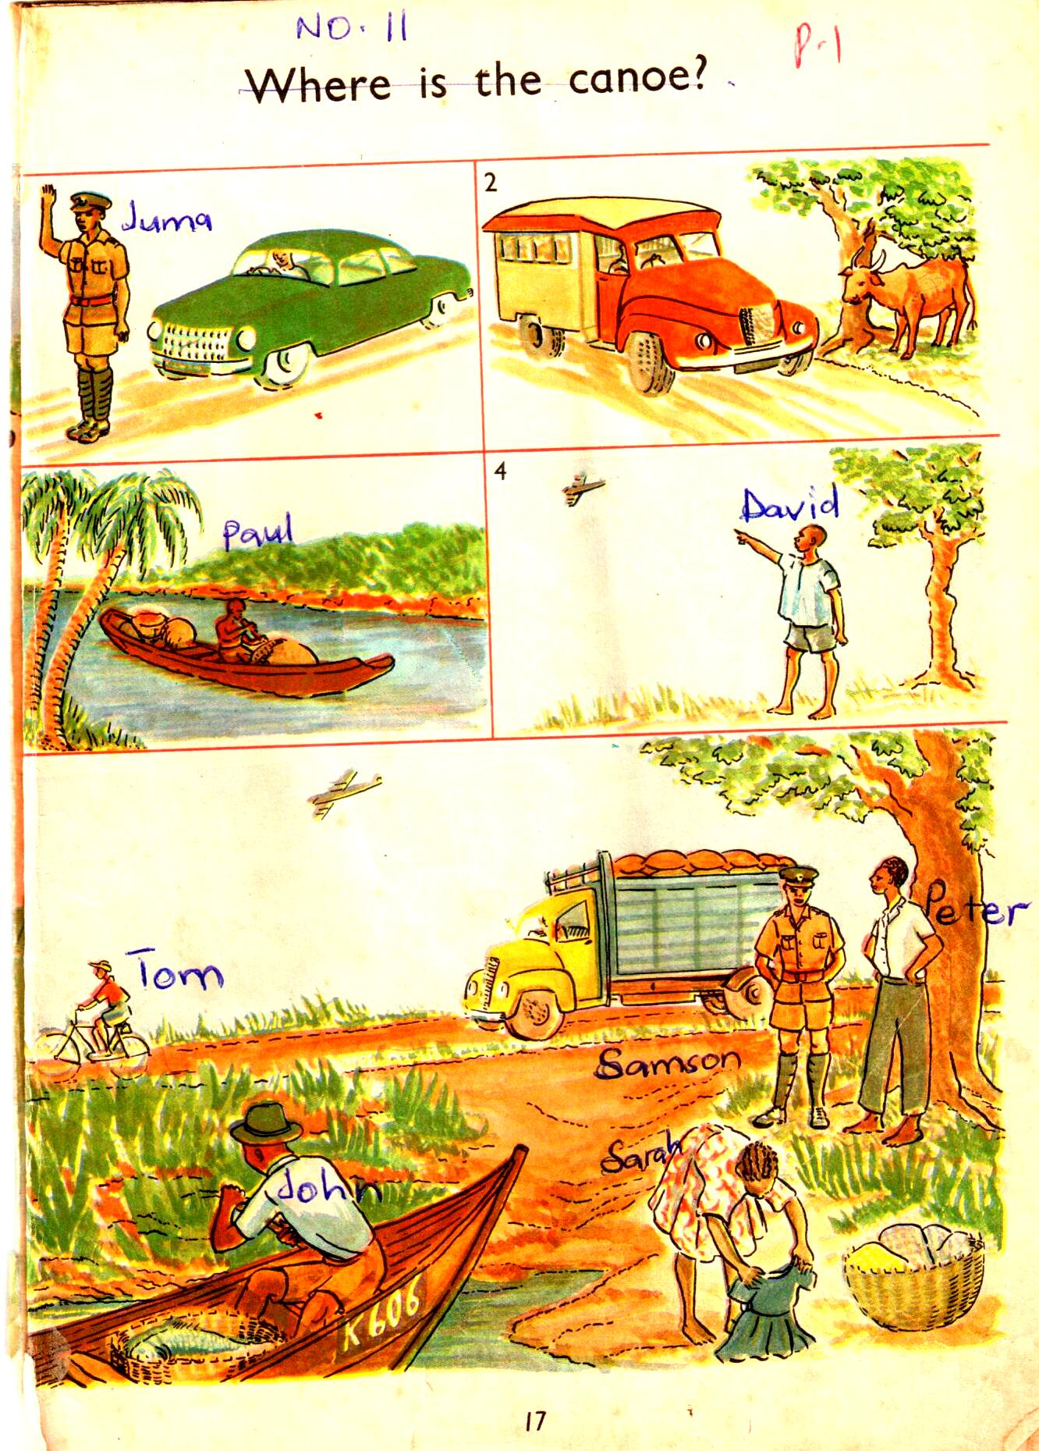

1. Who is pointing to the aeroplane?

_________________________________

1. What is the work of Juma?

_________________________________

1. Who is riding a bicycle

_________________________________

1. How many boats can you see in the pictures?

_________________________________

1. What can you see in picture number two?

_________________________________